Steve E. Watkins, John F. Unser, Antonio Nanni, K. Chandrashekhara, and Abdeldjelil Belarbi “Instrumentation and manufacture of a smart composite bridge for short-span applications”
8th Annual International Symposium on Smart Structures and Materials:
Smart Systems for Bridges, Structures, and Highways,
Proc. SPIE 4330, 4-8 March 2001, Newport Beach, CA

Instrumentation and manufacture of a
smart composite bridge for short-span applications

Steve E. Watkins*ª, John F. Unser**^{b}, Antonio Nanni***^{c},
K. Chandrashekhara****^{d}, and Abdeldjelil Belarbi*****^{c}
ªElectrical and Computer Engineering Department, Univ. of Missouri-Rolla;
^{b}Composites Products, Inc., St. Louis, Missouri; ^{c}Civil Engineering Department, Univ. of Missouri-Rolla; ^{d}Mechanical and Aerospace Engineering and Engineering Mechanics Department, Univ. of Missouri-Rolla;

ABSTRACT

A smart composite bridge is described that features an all-composite design and an integral sensor network. This short-span structure is nine meters in length and is designed for an AASHTO H20 highway load rating. The prototype bridge, the first full-composite bridge in Missouri, was installed on the University of Missouri-Rolla campus as a field laboratory for smart structures courses and a demonstration of composite technology. It was designed, analyzed, and manufactured as a cooperative product development among university, industry, and government partners. It has a modular construction based on a pultruded 76-mm-square composite tube. The cross section of the overall structural element is an I-beam formed by seven layers of bonded tubes. The top and bottom layers are carbon/vinyl-ester tubes for strength and the other layers are glass/vinyl-ester tubes for economy. Extrinsic Fabry-Perot interferometric fiber-optic sensors were embedded throughout to measure temperature, flexure strain, and shear strain. Also, radio-frequency identification tags were co-located with sensors to aid in determining load placement during field tests. This paper gives an overview of the project emphasizing the smart instrumentation. In particular, the installation of the integral sensors, the plan for the sensor network, and preliminary strain results for vehicle loading are discussed.
Keywords: Smart Structures, Composite Bridges, Fiber Optic Sensors, Health Monitoring

* watkins@umr.edu; phone 1 573 341-6321; fax 1 573 341-4532 ; http://www.ece.umr.edu; Univ. of Missouri-Rolla, Rolla, MO, USA 65409-0040;
** ets@inlink.com; phone 1 314 650-4470; Composite Products, Inc., 9417 S. Broadway, Suite 110, St. Louis, MO, USA 63125,
*** nanni@umr.edu; phone 1 573 341-4553; fax 1 573 341-6215 ; http://www.umr.edu/~civil; Univ. of Missouri-Rolla, Rolla, MO, USA 65409-0710;
**** chandra@umr.edu; phone 1 573 341-4587; fax 1 573 341-4115 ; http://www.umr.edu/~maem; Univ. of Missouri-Rolla, Rolla, MO, USA 65409-1350;
***** belarbi@umr.edu; phone 1 573 341-4478; fax 1 573 341-4729 ; http://www.umr.edu/~civil; Univ. of Missouri-Rolla, Rolla, MO, USA 65409-0030.
1. INTRODUCTION

Composite, or fiber-reinforced polymer, materials offer desirable mechanical properties, long-term durability, and fabrication flexibility.¹ Recent sensor advances offer in-situ monitoring of the geometric, environmental, and structural characteristics of civil engineering structures.²⁻⁵ Smart structures are possible in which health and performance are monitored throughout the lifetime of a structure.^{6,7} Although it is a relatively new area in civil engineering, the infrastructure applications of composite materials and integral smart sensors are increasing. The technology addresses growing needs for strengthening aging structures,^{8,9} rehabilitating damaged structures, and designing new structures to more stringent requirements and for longer service life. For the latter application, composite materials are useful for avoiding corrosion problems and environmental deterioration in bridges, masonry walls, ground anchors, piers, marine structures, etc. In particular, short-span bridges and bridge decks represent an enormous infrastructure investment across the nation and their maintenance is an ongoing expense.

Fiber optic sensors have been extensively tested for structural applications⁴ and have a recognized role in health monitoring of civil engineering structures.^{6,10-13} Their advantages include environmental ruggedness which offers the potential of long-term monitoring and operation in extreme conditions.^{3,4,14,15} In particular, fiber-optic sensors are compatible with composite materials due to their small size and temperature tolerances.^{16,17} Their performance and accuracy have been favorably compared to that of traditional electrical resistance strain gages in both static and dynamic applications.¹⁸⁻²¹ Instrumentation of laboratory structures and traditional bridges using fiber optic sensors has been demonstrated worldwide.²²⁻²⁷ Fewer demonstrations have been done with composite bridge structures.

This work describes a smart composite bridge for highway applications. This short-span structure features a composite construction and an integral sensor network. The prototype bridge, the first all-composite bridge in Missouri, was designed for an AASHTO H20 load rating²⁸ and its design was confirmed with a full-scale test article that was loaded to failure. It is located on the campus of the University of Missouri-Rolla. Although rated for highway applications, the normal usage is by pedestrians and light vehicles. The bridge was assembled from pultruded square tubes made of either carbon/vinyl-ester or glass/vinyl-ester. Extrinsic Fabry-Perot interferometric (EFPI) fiber-optic sensors were embedded throughout the structure to measure temperature, flexure strain, and shear strain. Also, radio-frequency identification tags were co-located with fiber-optic sensors to aid in determining load placement during field tests. This paper gives an overview of the project emphasizing the smart instrumentation. In particular, the installation of the integral sensors, the plan for the sensor network, and preliminary strain results for vehicle loading are discussed.

2. PROJECT BACKGROUND

2.1 Project overview
The project is a cooperative effort among an interdisciplinary faculty team at the University of Missouri-Rolla (UMR), the St. Louis-based Composite Products Inc., and the Navy Center of Excellence for Composites Manufacturing Technology (CECMT) at the Lemay Center for Composites Technology. The project goals were to develop a composite materials approach for extended-lifetime short-span highway bridges and to demonstrate advanced composites and sensing technology. Funding sources included a National Science Foundation grant, the Center for Infrastructure Engineering Studies (UMR), CECMT, the UMR Manufacturing Research and Training Center, and the Missouri Department of Transportation. Additional donations were provided as listed in the acknowledgements. The objectives were to design, laboratory test, manufacture, and evaluate a smart composite bridge as a long-term technological demonstration for industry and a field laboratory for UMR students. In particular, the bridge supports the new NSF-sponsored interdisciplinary course “Smart Materials and Sensors.” Project and course documentation can be found at http://www.umr.edu/~smarteng/.²⁹
The Smart Composite Bridge was installed on the UMR campus in the fall of 2000. The bridge deck was designed for an AASHTO H20 load rating and replaced a wooden bridge over a small creek that was 9.1-m long by 2.8-m wide. The design is based on a modular assembly of composite elements. The technology has the advantages of performance due to all-composite construction, of relative economy due to standard tube elements made from a pultrusion process, and of flexibility due to the modular use of carbon and glass tubes. The elements are square tubes with standard 76-mm (3-in.) sides and are reinforced with longitudinal carbon or glass fibers. The tube assembly consists of alternating layers of tubes that run longitudinally and transversely to the span length. The strength and deflection of the bridge assembly was tailored by the balanced use of higher-cost, higher-stiffness carbon tubes and lower-cost lower-stiffness glass tubes. A smart structures network fiber-optic sensors were incorporated for long-term in-situ monitoring of strain and temperature.

A sketch of the bridge is shown in Figure 1. Although the bridge was designed for highway loads, it is located along a concrete walkway used by pedestrians and light vehicles. Consequently, the wear surface and railings match this application. The wear surface is thin polymer concrete made from Transpo T-48 that was modified with a soybean-oil-based resin. The composite railings consist of pultruded glass tubes and carbon rods and of column plates made of sheet molding compound from recycled Ranger truck parts. The aesthetic design of the railing was determined by a contest among UMR students.

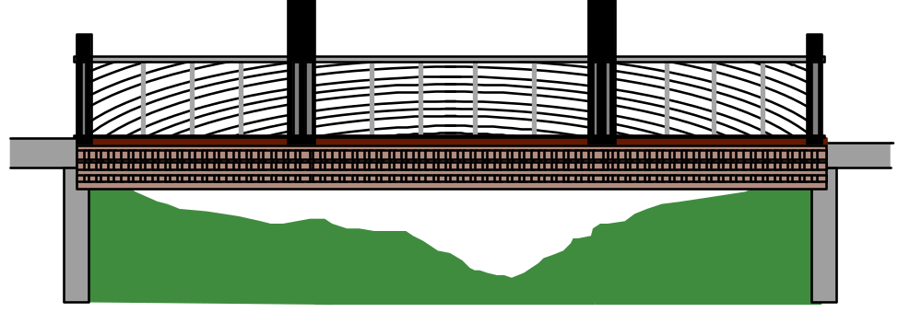

Figure 1 – Smart Composite Bridge Located on the UMR Campus

2.2 Technical development
The bridge development is summarized in Table 1. The target performance was AASHTO H20 for which a 142.4-kN (32,000 lbs.) axle weight produces no more than a 11.4 mm deflection for a 9.14 m span, i.e., a length/800 design criteria. A conservative safety factor of three was included. A combination of three-dimensional finite element analysis using ABAQUS and laboratory verification was applied to individual tubes, simple tube assemblies, and complex tube assemblies. Key laboratory test articles included a four-layer glass-tube beam of dimensions 2.44-m x 30.5-cm x 30.5-cm (8-ft x 1-ft. x 1-ft.) and an eight-layer carbon-and-glass I-beam of dimensions 9.14-m x 61.0-cm x 61.0-cm (30-ft. x 2-ft. x 2-ft.).

The four-layer beam was subjected to three-point loading to verify the finite element analysis and to determine the failure modes. Popping sounds were heard at a load of 89 kN (20,000 lbs.) and the transverse tubes began to deform at a load of about 111 kN (25,000 lbs.). Cracking of the tube corners was readily apparent at a load of 134 kN (30,000 lbs.). Debonding of tubes did not occur until a load of about 156 kN (35,000 lbs.). Strain and displacement measurements from fiber-optic sensors, electrical resistive gauges, and linear variable differential transformers (LVDTs) matched finite element predictions.

Two layers of carbon tubes separated by five tube widths were required to meet the deflection criteria for a 9.14-m span. An eight-layer I-beam configuration was adopted with carbon tubes at the bottom layer and the next-to-the top layer. These tubes were made in a resin matrix of Derakane 411-350 vinyl ester from Dow Chemical with reinforcement from longitudinal
Table 1: Chronology of Smart Composite Bridge Project

Main Project Tasks | Date
Design Work on the Project Begins | January 1999
Testing and Analysis of Simple Beam Assemblies Completed | January 1999
Approval of Campus Site and Completion of Railing Design | May 1999
Tube Specifications and Design of Bridge Finalized | Fall 1999
Carbon Pultrusion Process Finalized at LCCT | December 1999
Fatigue and Strength Tests of I-Beam Test Article | February – May 2000
Assembly of Bridge at LCCT | May – June 2000
Removal of Old Wooden Bridge | June 28, 2000
Installation of the Bridge Deck | July 29, 2000
Attachment of Railings and Sensor Patch Box | August 2000
Sensor Evaluation and Preliminary Load Tests | September – November 2000

fibers of Zoltek Panex 33 carbon and stitched mat on the inside and outside surfaces. These tubes were pultruded by Composite Products Inc. at the LCCT facility. The glass tubes were obtained from Bedford Reinforced Plastics using glass roving from Vetrotex America and CoRezyn resin from Interplastic Corporation. The beam was subjected to an initial deflection test and a two-million-cycle fatigue test between 48.9 kN (11,000 lbs.) and 2.2 kN (500 lbs.). The deflection at the AASHTO H20 loading of 35.5 kN (8,000 lbs.) was 6.6 mm which is fifty-eight percent of the target 11.4-mm deflection. No loss of stiffness was detected for the fatigue test. A four-point load-to-failure test was conducted as shown in Figure 2. The beam was elastic until a load of about 134 kN (30,000 lbs.) for which loud popping sounds were heard. Significant failure, i.e., cracking of the corners of tubes, occurred at a load of 156 kN (35,000 lbs.). The failure was non-catastrophic resulting in no permanent distortion of the I-beam when the load was removed. Strain measurements from fiber-optic sensors, electrical resistive gauges, and LVDTs monitored the failure behavior. The top transverse layer of tubes was deemed unnecessary in light of the failure performance and eliminated from the final bridge design.



Figure 2 – Setup for Loaded-to-Failure Test of I-beam Test Article
3. SMART COMPOSITE BRIDGE

3.1 Bridge manufacture
A cross section of the Smart Composite Bridge is shown in Figure 3. It consists of seven layers of tubes. The load is distributed over four I-beam structures. The bottom two layers and the top two layers are continuous. The bridge was assembled by the industry partner, Composite Products Inc. Load-bearing carbon/vinyl-ester tubes are used in the bottom and top layers. These tubes were pultruded at LCCT by the industry partner. Glass/vinyl-ester tubes are used elsewhere. All tubes are identical to those in the I-beam test article. Tubes were coated with epoxy, and then they were screwed and clamped to maintain position during cure. A consistent spacing was maintained between adjacent tubes by fine spacer wires. Details and images of the manufacturing and installation process are given on project web site.²⁹

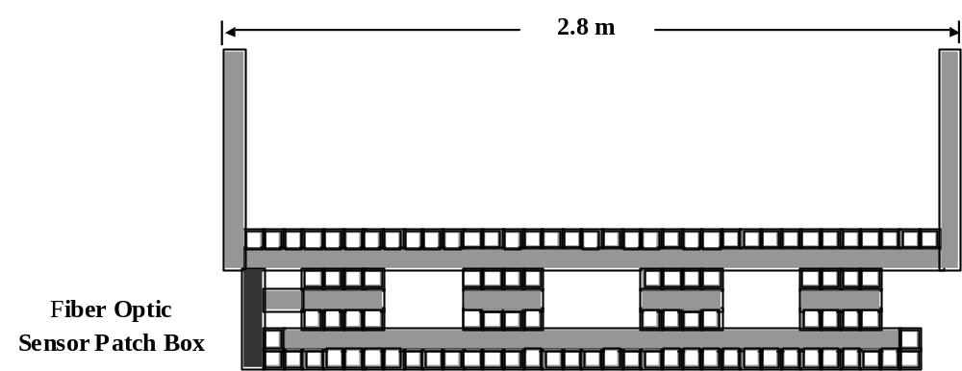

Figure 3 – Cross Section of the Bridge. Fiber-optic sensors are located in the top and bottom layers to measure flexure strain and are located on the web of the left I-beam web to measure shear strain and temperature. The sensor patch box is shown at far left.

3.2 Sensor handling
Fiber optic sensors were incorporated within the structure during assembly as shown in Figure 4. They were placed in small grooves on the tube surfaces to provide protection from impacts during assembly steps and to move the sensors away from the interface between tubes. The strain measurements by each sensor should be associated with only one tube and not complicated by possible interface effects. The sensors were tacked in place after cleaning the groove with acetone. The sensor leads were routed toward the end of the bridge along the interface between tubes. Then, the sensors and leads were covered with epoxy during the surface preparation of the next layer of tubes. A fiber optic sensor patch box is located at one corner of the bridge deck. The ends of the leads were carried inside transverse tubes to the sensor patch box.

3.3 Bridge installation
The all-composite design for the bridge resulted in a light-weight structure compared to traditional highway bridges. Consequently, the bridge deck was assembled and the railings fitted at the LCCT facility in St. Louis, Missouri. The deck and railings were later transported by truck to the campus site. St. Louis Local Union #396 of the International Association of Bridge, Structural, Ornamental, and Reinforcing Ironworkers donated the crane and labor for bridge installation. The setup of the crane and the placement of the bridge were done in less than three hours on July 29, 2000. The ends of the bridge rest on bearing pads set on 18-cm-wide concrete abutments (see Figure 1). Composite anchors were embedded in the concrete abutments and passed through holes at each bridge corner in the two lower layers to prevent lateral movement. Afterward, the permanent attachments of the railings and the sensor patch box were completed.



Figure 4 – Fiber optic sensors are placed on the bottom layer during assembly.

4. SENSOR INSTRUMENTATION

4.1 Sensor description
A fiber-optic sensor system made by Luna Innovations of Blacksburg, Virginia was used for the experimental work. This AFSS-PC system uses extrinsic Fabry-Perot interferometric (EFPI)⁴ fiber-optic sensors to measure absolute strain and temperature. A sensor schematic is shown in Figure 5(a). It utilizes multiple-beam interference³⁰ in a cavity formed between two polished, coated end-faces of optical fiber.^{14,31-34} A capillary tube is bonded to the fibers and maintains the alignment of their end-faces. Strain on the capillary tube produces changes in cavity length which modulate the irradiance of returned light in the fiber. The sensor has little transverse coupling and effectively evaluates the axial component of strain.^{18,35} The gage length is determined by the length of this capillary tube rather than the cavity and can be built to varying lengths. EFPI strain sensors can measure strain given the gauge length and EFPI temperature sensors measure temperature using known internal thermal expansion behavior. High-finesse strain sensors were used with gage lengths of about 8 cm or 4 cm.

The AFSS data-acquisition and processing system is shown in Figure 5(b). Absolute cavity displacement is demodulated from multiple measurements at several different wavelengths. A broadband LED source is used that is centered about a wavelength of 830 nm. The input light is directed to the sensor by a fiber coupler and the returned light is sent to a wavelength demodulator and detector. Up to seven sensors can be multiplexed at a scanning rate of one-Hertz per sensor channel, although the preliminary measurements were not multiplexed.

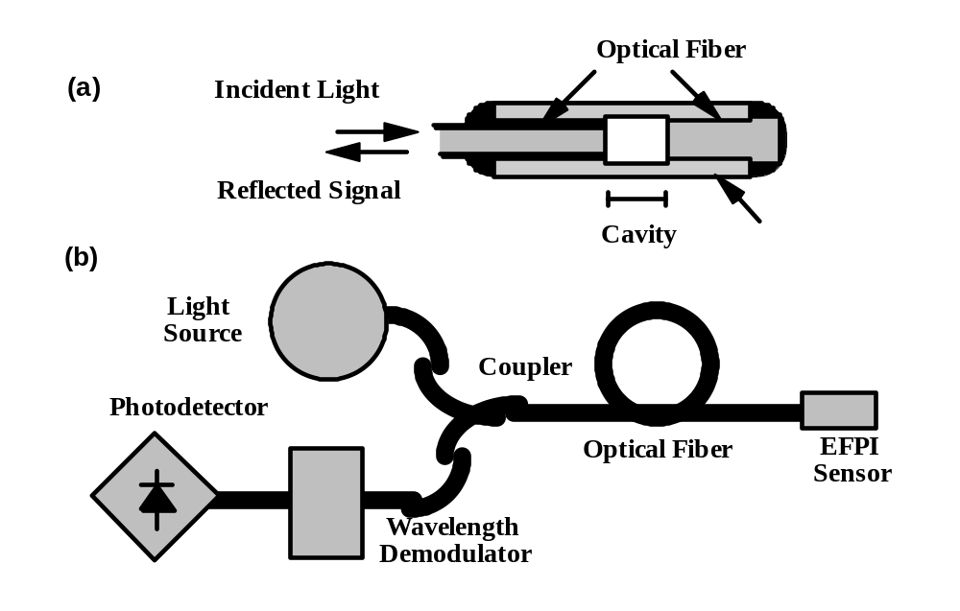
Figure 5 – Sensor System: (a) Extrinsic Fabry-Perot interferometric (EFPI) sensor with an external air-gap cavity and coated high-reflectance fiber surfaces. (b) EFPI fiber optic sensor and support instrumentation for absolute strain measurement.

Twenty-four EFPI strain sensors and one EFPI temperature sensor were embedded throughout the bridge.³⁶ Sixteen sensors were placed in the top and bottom load-bearing carbon layers and distributed across the mid-span to measure flexure strain. Also, a strain sensor was placed at the north and south quarter-span positions. A three-sensor rosette was installed for shear strain near the end of the bridge on an I-beam web (third layer from the bottom). An addition, three strain sensors and one temperature sensor was installed on the middle layers of an I-beam web. In addition, radio-frequency identification tags were bonded on the upper surface of the top layer of tubes and covered with the resin wear surface. Two pieces of nonconductive cloth sandwiched the tags to isolate them electrically. These tags were located at each strain sensor position to provide a direct means to determine these locations. All identification tags are working in the installed bridge.

All sensors were tested after completion of the bridge at the manufacturing facility and following installation at the campus site. Fourteen, or fifty-six percent, of the EFPI sensors are working in the completed bridge. Two of the mid-span sensors were broken during internal routing in the manufacture process and eight sensors were apparently broken during transport and installation of the bridge deck. The surviving sensors are providing measurements of dynamic and static load-induced strains and temperature-induced strains.

4.2 Preliminary measurements
The working sensors were monitored on days with greatly different temperatures and for a light load provided by a Ford F-150 pickup truck. The testing days in the fall of 2000 were 21 degrees Celsius (70 degrees Fahrenheit) and zero degrees Celsius (32 degrees Fahrenheit). On the warmer day, the mid-span sensors gave an unloaded, temperature-induced strain that was about 23 microstrain higher and 14 microstrain higher for the top layer and the bottom layer, respectively.

The load tests with the pickup truck were done on the warmer day, i.e., the 21-degrees-Celsius day. The truck was weighted and found to have a front-axle weight of 12.0 kN (2,700 lbs.) and a back-axle weight of 9.6 kN (2,150 lbs.). The front axle weight was 8.4 percent of an H20 load rating of 142.4 kN (32,000 lbs.).²⁸ The central mid-span sensors in the top and bottom layers were interrogated with the front axle placed at mid-span as shown in Figure 6. The static strains were 7.2 microstrain tension for the central bottom-layer sensor and 7.0 microstrain compression for the central top-layer sensor. In addition, a dynamic measurement at a 4.5-Hertz sampling rate was recorded for the truck slowly driving across the bridge (see Figure 7). The strain smoothly decreased to the maximum loaded value and then increased back to the unloaded value.

Figure 6 – Preliminary Load Test using a Ford F-150 Pickup Truck. The front-axle load was 8.4 percent of the H20 load rating.

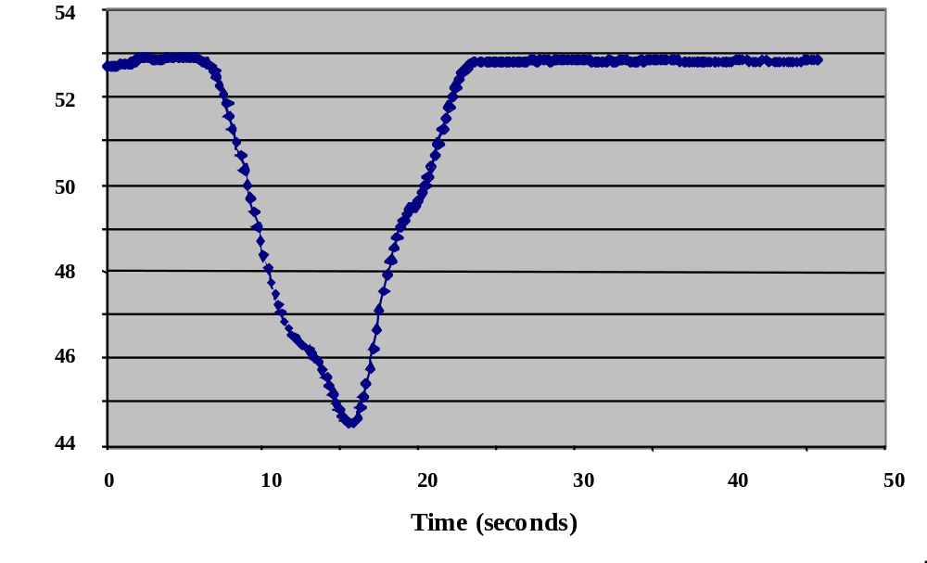
Figure 7 – Compressive Strain in the Top Layer at Mid-span during Dynamic Loading
5. SUMMARY

A prototype short-span bridge was manufactured for an AASHTO H20 load rating and was instrumented with EFPI fiber-optic sensors. The project was a cooperative product development among the university, industry, and government partners. The bridge features an all-composite design using standard pultruded tubes and an embedded sensor network for in-situ long-term monitoring. I-beam structural elements were assembled from seven bonded layers of tubes. The top and bottom layers are carbon/vinyl-ester tubes for strength and the other layers are glass/vinyl-ester tubes for economy. The fiber-optic sensors measure flexure strain at mid-span and quarter-span and measure shear strain near the abutments. A four-layer tube assembly and a full-scale I-beam test article were loaded to failure to confirm the failure modes and bridge design. The failure load of the full-scale test article exceeded target specifications by almost a factor of four. Other showcased technologies include soybean-based composite resins, recycled composite material, and radio-frequency identification tags. Further text and graphic documentation of the project can be found at http://www.umr.edu/~smarteng/bridge.²⁹ This site includes a live image of the final structure as monitored from a network web CCD camera from Axis Communications (see Figure 8).

Twenty-four EFPI sensors were embedded throughout the bridge. Two sensors were broken during internal routing in the manufacture process and eight sensors were broken during transport and installation of the bridge deck. Fourteen sensors survived the entire manufacturing and installation processes. They are providing reasonable dynamic and static load-induced strains and temperature-induced strains. A preliminary load test has been done using a Ford F-150 pickup truck. The sensors monitored the small strain produced by this light load. The front axle of the truck was 12.0 kN (2,700 lbs.), which is 8.4 percent of the H20 load rating of 142.4 kN (32,000 lbs.).

This Smart Composite Bridge was installed on the campus of the University of Missouri-Rolla as a long-term demonstration of composite technology and as a field laboratory for smart structures courses and research. A dedicated fiber-optic data line will soon be installed for remote monitoring. Also, further experimental tests and theoretical research are in progress. This extended work will examine the elastic behavior of the bridge for various dynamic and static loads within the H20 rating, will compare experimental strain measurements to a full finite element analysis, and will monitor the durability of the component materials.



Figure 8 – Web Image of the Smart Composite Bridge in the Library Park of UMR

ACKNOWLEDGMENTS

This work was sponsored by the National Science Foundation (under CRCD Grant # EEC-9872546 with Mary Poats as technical contact), the Center for Infrastructure Engineering Studies (UMR), the Navy Center of Excellence for Composites Manufacturing Technology (CECMT), the UMR Manufacturing Research and Training Center, and the Missouri Department of Transportation. Composite fabrication and bridge assembly were performed at the Lemay Center for Composites Technology, which is the facility in St. Louis, Missouri for CECMT. The on-site installation was done by the International Association of Bridge, Structural, Ornamental, and Reinforcing Ironworkers, Local Union #396, St. Louis, Missouri. Martha J. Molander of the UMR Electrical and Computer Engineering Department installed the smart instrumentation and performed the preliminary load tests. The donation of the radio-frequency identification, RFID, tags by John Belk is gratefully acknowledged. Also, the following companies donated material for the bridge: Luna Innovations, Inc., Blacksburg, VA (suppliers of fiber optic sensors and instrumentation), Boeing, St. Louis, MO (loan of RFID tag reader), Missouri Soybean Merchandising Council (soybean-based resin for surface and railing rods), Zoltek, St. Louis, MO (donation of carbon for tubes and rods), Dow Chemicals (donation of resin for carbon tubes), Glass Industries (donation of fiberglass mat for carbon tubes), Albemarle Corporation (donation of flame retardant for carbon tubes), Vetrotex America (donation of fiberglass roving for glass tubes), Interplastic Corporation (donation of vinyl ester resin), and Dexter (donation of adhesive for bonding tubes).

REFERENCES

1. S. Bassett, ed., Composites for Infrastructure: A Guide for Civil Engineers, (Ray Publishing Company, 1998).
2. I. Chopra, “Review of Current Status of Smart Structures and Integrated Systems,” SPIE Proc., 2717, 20-62 (1996).
3. R. M. Measures, “Advances Toward Fiber Optic Based Smart Structures,” Opt. Eng., 31(1), 34-47 (1992).
4. Eric Udd, Fiber Optic Smart Structures (John Wiley and Sons, Inc., New York) 1995.
5. A. E. Aktan, A. J. Helmicki, and V. J. Hunt, “Issues in Health Monitoring for Intelligent Infrastructure,” Smart Mater. Struct., 7(5), 674-692 (1998).
6. B. Culshaw, C. Michie, P. Gardiner, and A. McGowan, “Smart Structures and Applications in Civil Engineering,” Proceedings of the IEEE, 84(1), 78-86, (January 1996).
7. W. B. Spillman, Jr., “Sensing and Processing for Smart Structures,” Proceedings of the IEEE, 84(1), 68-77, (January 1996).
8. A. Nanni and C. W. Doolan, eds., FRP Reinforcement for Concrete Structures, ACI SP-138, (American Concrete Institute, Detroit, MI 1993).
9. ACI Committee 440, “State of the Art Report on FRP for Concrete Structures,” ACI440R-96, Manual of Concrete Practice, (ACI, Farmington Hills, MI, 1996), 68.
10. A. Mendez, T. F. Morse, and F. Mendez, “Applications of Embedded Fiber Optic Sensors in Reinforced Concrete Buildings and Structures,” SPIE Proc., 1170, 60-69 (1989).
11. C. I. Merzbacher, A. D. Kersey, and E. J. Friebele, “Fiber Optic Sensors in Concrete Structures: A Review,” Smart Mater. Struct., 5(2), 196-208 (1996).
12. R. W. Griffiths, “Structural Monitoring of Bridges using Fiber Optic Sensors,” SPIE Proc., 2446, 127-139 (1995).
13. F. Ansari, ed. Fiber Optic Sensors for Construction Materials and Bridges, (Technomic Publishing Co., Inc., Lancaster, PA, 1998).
14. W. Zhao, J. Wang, A. Wang, and R. O. Claus, “Geometric Analysis of Optical Fiber EFPI Sensor Performance,” Smart Mater. Struct., 7(6), 907-910 (1998).
15. M. B. Reid and M. Ozcan, “Temperature Dependence of Fiber Optic Bragg Grating at Low Temperature," Opt Eng., 37(1), 237-240 (1998).
16. A. M. Vengsarkar, K. A. Murphy, M. F. Gunther, A. J. Plante, and R. O. Claus, “Low Profile Fibers for Embedded Smart Structure Applications,” SPIE Proc., 1588, 2-13 (1991).
17. D. W. Jensen, J. Pascual, and J. M. Cory, Jr., “Dynamic Strain Sensing of a Composite Lattice with an Integrated Optical Fiber,” J. of Intell. Mater. Syst. and Struct., 2, 198-214 (1991).
18. F. Akhavan, S. E. Watkins, and K. Chandrashekhara, “Measurement and analysis of impact-induced strain using extrinsic Fabry-Perot fiber optic sensors,” Smart Mater. Struct., 7(6), 745-751 (1998).
19. M. de Vries, M. Nasta, V. Bhatia, T. Tran, J. Greene, R. O. Claus, and S. Masri, “Performance of Embedded Short-Gage Length Optical Fiber Sensors in a Fatigue-Loaded Reinforced Concrete Specimen,” Smart Mater. Struct., 4(1A), A107-A113 (1995).
20. A. M. Gallon, L. A. Everall, J. Brickwood, I. Campbell, and H. L. Davies, “Optical Fibre Strain Sensing for Use in Structural Life Cycle Analysis,” Structural Monitoring Conference, BSSM, Glasgow, Scotland, 11 November 2000.
21. V. Zetterlind III, S. E. Watkins, and M. Spoltman, “Fatigue Testing of a Composite Propeller Blade using Fiber-Optic Strain Sensors,” submitted to Appl. Opt.
22. D. R. Huston, P. L. Fuhr, T. P. Ambrose, and D. A. Barker, “Intelligent Civil Structures – Activities in Vermont,” Smart Mater Struct., 3(2), 129-139 (1994).
23. R. M. Measures, A. T. Alavie, R. Maaskant, M. Ohn, S. Karr, and S. Huang, “A Structurally Integrated Bragg Grating Laser Sensing System for a Carbon Fiber Prestressed Concrete Highway Bridge,” Smart Mater Struct., 4(1), 20-30 (1995).
24. R. L. Idriss, M. B. Kodindouma, A. D. Kersey, and M. A. Davis, “Multiplexed Bragg Grating Optical Fiber Sensors for Damage Evaluation in Highway Bridges,” Smart Mater. Struct., 7(2), 209-216 (1998).
25. D. Inaudi, S. Vurpillot, N. Casanova, and P. Kronenberg, “Structural Monitoring by Curvature Analysis using Interferometric Fiber Optic Sensors,” Smart Mater Struct., 7(2), 199-208 (1998).
26. P. L. Fuhr, D. R. Huston, and B. MacCraith, “Embedded Fiber Optic Sensors for Bridge Deck Chloride Penetration Measurement,” Opt Eng., 37(4), 1221-1228 (1998).
27. W. Lee, J. Lee, C. Henderson, H. F. Taylor, R. James, C. E. Lee, V. Swenson, R. A. Atkins, and W. G. Germeiner, “Railroad Bridge Instrumentation with Fiber-Optic Sensors,” Appl. Opt., 38(7), 1110-1114 (1999).
28. American Association of State Highway and Transportation Officials (AASHTO), Standard Specifications for Highway Bridges, 16th ed. (AASHTO, Washington, D.C., 1996).
29. S. E. Watkins and R. H. Hall, “Smart Materials and Sensors” and “Smart Composite Bridge,” Smart Engineering Project, (2001). Available WWW: http://www.umr.edu/~smarteng/.
30. M. Born and E. Wolf, Principles of Optics, 6th ed. (Pergamon Press, New York, 1980).
31. T. Yoshino, K. Kurasawa, and I. Katsuji, “Fiber-Optic Fabry-Perot Interferometer and its Sensor Applications,” IEEE J. Quantum Electronics, 10, 1624-1633 (1982).
32. A. D. Kersey, D. A. Jackson, and M. Corke, “A Simple Fiber Fabry-Perot Sensor,” Opt. Commun., 45, 71-74 (1983).
33. D. Hogg, D. Janzen, T. Valis, and R. M. Measures, “Development of a Fiber Fabry-Perot Strain Gauge,” Proc. SPIE, 1588, 300-307 (1991).
34. K. A. Murphy, M. F. Gunther, A. M. Vengsarkar, and R. O. Claus, “Quadrature Phase-Shifted, Extrinsic Fabry-Perot Optical Fiber Sensors," Opt. Lett., 16(4), 273-275 (1991).
35. J. S. Sirkis, “Phase-Strain-Temperature Model for Structurally Embedded Interferometric Optical Fiber Sensors with Applications,” SPIE Proc., 1588, 26-43 (1991).
36. M. J. Molander, “Instrumentation of a Smart Composite Bridge,” M.S. Thesis, University of Missouri-Rolla, 2001.

